Propensity Score-Based Methods for Causal Inference

Module 8: Impact of Unmeasured Confounding

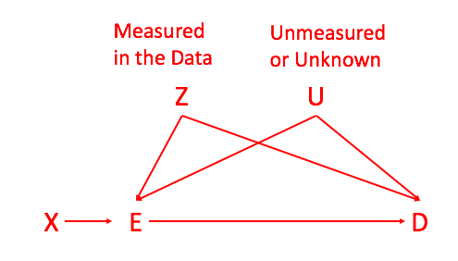

**I. Module Objectives**

Although propensity score-based methods can be a set of useful tools for analyzing observational data in a way that better emulated randomized trials, they also depend on measuring confounders in the data. Although we have no way of guaranteeing that all confounders are measured in the data, we can assess the sensitivity to unmeasured confounding (Lin, et al., 1998). The basic idea of sensitivity methods is to evaluate, over a range of hypothetical effects for the unmeasured confounders, whether the result of a given analysis change in terms of statistical significance (from significant to non-significant).

By the end of this module, you will be able to:

1. Describe the concept of sensitivity analysis
2. Develop a plan to assess sensitivity of your analysis to unmeasured confounding

**II. Module Assignments**

**Required Assignments: (~9 minutes + reviewing software routines)**

For an overview of sensitivity methods, watch the first 9 minutes of Module 8 of Category 8 (on causal inference) of the PCORI Methodology Standards Academic Curriculum. This module discusses a broad range of assumptions and sensitivity analyses; the first 9 minutes of the video are most relevant to propensity score analyses.

For a list of routines in R, Stata or Excel, for conducting sensitivity analyses to unmeasured confounding, see Elizabeth Stuart’s website at <http://www.biostat.jhsph.edu/~estuart/propensityscoresoftware.html>

**Optional Assignments: (~27 pages to read)**

For more specific technical details on one approach to sensitivity for unmeasured confounding, read the following article: Lin, D.Y., Psaty, B.M. and Kronmal, R.A., 1998. Assessing the sensitivity of regression results to unmeasured confounders in observational studies. *Biometrics*, pp.948-963.

For a more general framework on quantifying bias in different scenarios, read the following article: VanderWeele, T.J. and Arah, O.A., 2011. Bias formulas for sensitivity analysis of unmeasured confounding for general outcomes, treatments, and confounders. *Epidemiology (Cambridge, Mass.)*, *22*(1), pp.42-52.

**III. Project Exercises**

Create a copy of this Google Doc or download the Module onto your computer and review the material offered above under Module Assignments before beginning these workbook exercises.

Thinking about what you learned in this module so far, begin developing the analysis plan for your project by answering the following questions:

1. Think about potential sources of confounding that are not measured directly in your data.

First consider whether you may be able to capture variability in any such unmeasured confounders using complex functions of the confounders you have measured.

For instance, identifying patients with multiple comorbidities might something you can do based on their age and other measures of health status that are different from, but related to the comorbidities of interest.

If this is the case, ask whether the assignment mechanism model from Module 5 is sufficiently complex to capture that relationship. If not, consider using other models for the assignment mechanism.

1. For unmeasured confounders that cannot be captured in the observed data, ask how large of an effect might be reasonable to assume between those unmeasured confounders as a whole and the outcome. This will inform your eventual interpretation of any subsequent sensitivity analysis.
2. Review the software tools available for sensitivity analysis of unmeasured confounding.

Many times, these sensitivity methods (although the concept is very general) are programmed specific to one type of pseudo randomization method (e.g. a specific type of matching approach). Can you find a software package that performs the method that directly relates to your pseudo population and outcomes model methods?

[Link to go back to the Course Overview Document](https://docs.google.com/document/d/1UDTkp3rbhqdun7jvSvktaZmTtoUWOz_VUDQw3HIsElg/edit?usp=sharing)